ANNUAL REPORT

APRIL 2023

LIST OF REPORTS

- Chairman’s Report
- Minutes of the Annual Parochial Church Meeting held on Sunday 10th April 2022
- Parochial Church Council Report
- Treasurer’s Report
- External Giving Report
- Churchwardens’ Fabric Report
- Safeguarding Report
- Children’s Church Report
- Little Ted Report
- Godzone Report
- Home Groups’ Report
- Drop-in and Community Lunch Report

- Chairman’s Report

On the 26th March 2022 we met as a church to think about our calling and vision for the future of our church. A few things emerged which we have been working on this year, divided into things which will help us grow in our discipleship and things which will engage our communities outside the church.
Starting then with our own discipleship: We committed to starting to share stories with each other of what God is doing in our lives so that we might be encouraged and build confidence that God is at work not just in some of our lives, but in all of our lives. We thought about our vision for our home groups and the focus on not just getting to grips with the bible, but also helping each other to grow in following Jesus in areas like prayer, sharing faith, showing Jesus love to others and so on. Throughout the year we have met at times in separate groups ,and at times together, and this has helped us to feel more as one church moving forwards together but has also been fascinating to share ideas between those in different groups. We have not started to run the courses we wanted to see run, particularly pertaining to exploring faith and hearing from God, but we will get there.
Relating to our community, we wanted to start to run events which would attract a wider group of people and this has started to happen, particularly with the Summer Fun Day on the green, but also with the men’s and women’s events which continue to build. Our seasonal services have been very well attended, and we are looking to help more people find their place at St Mary’s over the rest of the year. One area we wanted to improve was helping people to join and then integrate into the family of the church, and it is now far easier for people to join and to find a home group to attend as they are more well publicised. We have increased the use of social media and advertising to promote our events.
As part of our thinking we have been evaluating whether tweaking the style of our service and the time it is on might help more people to engage. With this in mind, we have been preparing to launch a monthly afternoon service which will happen for the first time in March 2023 with a café style all age flavour. The PCC is very much continuing to think missionally and creatively and we look forward to what 2023 will bring.
I would like to take this opportunity to thank you all for the ways you have stepped up and served the church and the community. Many churches have a small minority of people doing most of the work, but at St Mary’s we are a family and everyone pitches in. My sincere thanks to you all and to Paul who has continued to lead us with great faithfulness.
Bless you all.

Matt Levinsohn

- Minutes of the Annual Parochial Church Meeting held during the morning service on Sunday 10th April 2022
Present: Matt Levinsohn (chairman), Mike Shaw (secretary), Paul Clayton, Brian Wake, Gill Clayton, Lewis Ayers, Christine Ayers, Cheryl Moore, Terry Reed, Mark Nile, Julie Nile, Sonia Wade, Steven Firth, Jane Firth, Ann Smith, Maurice Bainbridge, Edwina Bainbridge Chris Brown, Christine Burnell, Mike Charlesworth, Shirley Charlesworth, Andrew Evans.
A total of 22.
- Welcome
Words of welcome, opening prayer. As is our custom, the APCM was incorporated into our Sunday morning service.
- Election of Churchwardens
There were two nominations: Mark Nile and Terry Reed, who were declared duly elected to serve as Churchwardens for the coming year. Matt Levinsohn thanked Mark and Christine Ayers for their service to St Mary's throughout the year, and especially to Christine who was standing down after many years of service.
- Apologies for Absence
Jenny Lewis, Ann Moss.
- Approval of Minutes
The minutes of the 2021 APCM were accepted as a true record.
- Electoral Roll Report
Jane Firth reported that there are 57 names on the electoral roll. This is an increase of 2 since last year as there having been 2 deaths and 4 new names.
- Election of new PCC Members
The PCC works on a three-year term basis i.e. after three years, members step down or seek re-election.
The following were re-elected: Gill Clayton, Christine Ayers.
Clergy, Church Wardens, and the Deanery Synod Representative are automatically members of the PCC. In addition, based on the number of names on the electoral roll, St Mary’s is entitled to 9 elected members. These are now: Lewis Ayers, Mike Shaw, Brian Wake, Steven Firth, Jane Firth, Gill Clayton, Jenny Lewis, Ann Moss, Christine Ayers.
- Annual Report
The 2022 Annual Report on all of St Mary’s activities had been prepared and circulated in advance of the meeting. Thanks were expressed to all those who had contributed.
- Presentation of Accounts
The accounts for the year ending 31st December 2021 had been circulated in the 2022 Annual Report. There were no questions on finance.
- Appointment of Auditor
Steven Firth proposed that Roger Stevenson, the auditor of the Church's accounts last year, be asked to be the auditor for 2022-2023. The proposal was seconded by Mike Shaw and was accepted.
- Closing Prayer
Michael Shaw - Secretary

- Parochial Church Council Report (PCC)
The Council currently consists of:
- 9 elected representatives of the laity
- the clergy
- the two churchwardens
- the Deanery Synod representative

The elected representatives were:
Lewis Ayers, Steven Firth, Jane Firth, Brian Wake, Jenny Lewis, Christine Ayers, Gill Clayton, Ann Moss and Mike Shaw.
Mark Nile and Terry Reed (as church wardens), Matt Levinsohn and Paul Clayton (as clergy) and Cheryl Moore (as deanery synod representative), were ex-officio members of the council.
The Council has met six times (ie every 2 months) during the year.
The minutes of each meeting are displayed on the porch noticeboard and published on St Mary’s website.
Officers of the Council were:
- Chairman: Matt Levinsohn
- Lay Vice-Chairman: Brian Wake
- Treasurer: Lewis Ayers
- Secretary: Mike Shaw

Other Officers reporting to the council were:
- Electoral Roll Officer: Jane Firth
- Safeguarding Officer: Christine Burnell

The Standing Committee, charged with dealing with matters of urgency arising between Council meetings consisted of Matt Levinsohn (chair), Paul Clayton, Mark Nile (warden), Terry Reed (warden) and Cheryl Moore.
At each PCC meeting, the Council considers reports and communications from the following:
- Safeguarding officer
- Treasurer
- Deanery Synod representative
- Building & Maintenance

The Council, where necessary, determines further actions on these matters and on any other business raised.
Reports on St Mary’s activities are covered elsewhere in this Annual Report.
Michael Shaw - Secretary

- Treasurer’s Report
Although most reports to the APCM are for the period ended April, the church financial year is the calendar year and so this finance report is in respect of the period January to December 2022.
GENERAL CURRENT ACCOUNT (Unrestricted Funds) We budgeted for a deficit of £4,000 in 2022. The actual outcome was a surplus of £985 which is a very pleasing result. In summary, the changes compared with budget were:
Spending
Spending was just £1,748 more than budget, but that included £1,000 transferred to the Fabric Account, so the true additional external spend was just £748.
We donated an additional £1,000 Parish Share and £515 of External Giving which was from funeral donations, plus we paid £990 for the architect’s quinquennial inspection. That £2,505 of additional spending was partly offset by savings on other items.
Income
The aggregate of congregational giving (Regular Giving plus Cash Collections) was in line with budget. (Cash collections £1,200 more. Regular Giving £1,400 less than budget.)
We received an additional £1,471 in tax refund.
We received an additional £1,300 in service fees.
We received £3,000 in one-off donations from members of the church family.
We received in December an unexpected £1,012 from the Central CofE to offset energy costs.
As a result, our income was £6,733 more than budgeted.
As a result of the above, the year-end balance in the current account was £10,838.

BUILDING FABRIC ACCOUNT (Restricted Funds) 2022 was a very expensive year, primarily due to work requirements advised by the architect following his 5-yearly quinquennial inspection.

In summary, the work carried out was:
Minor repair to heating £60
Repairs to Chapel Roof £690
Major Replacement of Heating Boiler Burner £2,364
5-Yearly Electrical Systems Check £839

From quinquennial Report:
Digital Survey of Londonderry Chapel £900
Masonry Repairs & Repointing £ 4,765
Sub-Total excluding insurance item £ 9,618

This was paid for by:
Congregation Regular Monthly Donations £608
Congregation Special Donations £2,940
Donation from Thursday Drop-In £500
Donation from Lord Londonderry £1,657
Use of Reserves £3,915
Total £9,618

We also successfully completed the replacement of the stone cross above the bellcote at a cost of £4,765 but that cost was met by an insurance settlement.
As a result, the year-end balance in the Fabric Account was reduced to £1,414 .
My thanks to everyone, including our auditor, Roger Stevenson.
Lewis Ayers - Treasurer

Attachments:
Table 1 Main Current Account Performance Against Budget
Table 2 Current Account Details
Table 3 Fabric Account Details

TABLE 1 : CURRENT ACCOUNT – PERFORMANCE AGAINST BUDGET
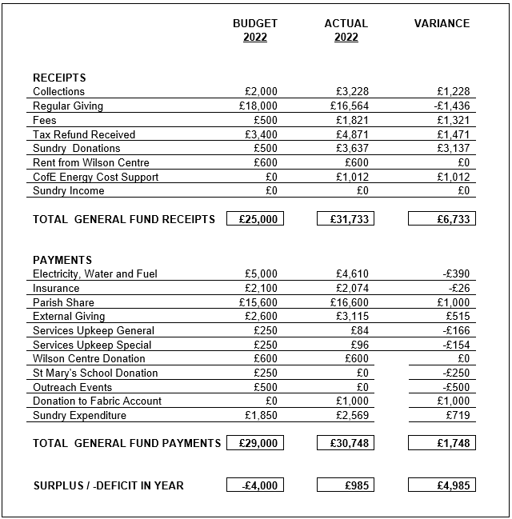

Sundry Expenditure 2022
Annual Copyright Licence  Gardening | £ 87  £ 524
Architect Fees | £1,332
Covid Test Kits | £ 19
Fire Extinguisher Annual Maintenance | £ 30
Organ Annual Service | £ 156
Heating Annual Service | £ 288
Sundry Others (coffee, toilet rolls, etc) | £ 133
TOTAL | £2,569

TABLE 2 : CURRENT ACCOUNT DETAILS
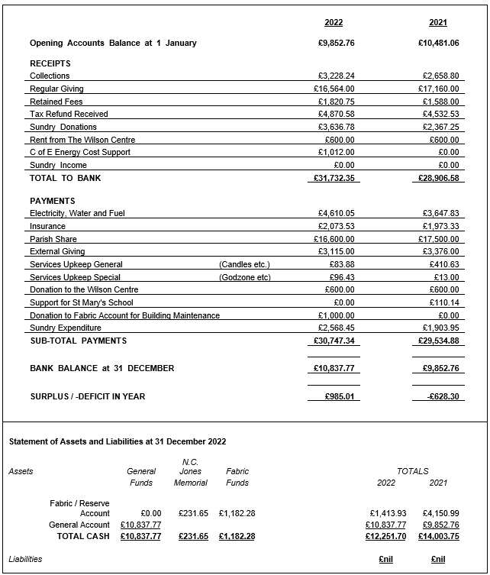

TABLE 3 : BUILDING FABRIC & RESERVE ACCOUNT DETAILS
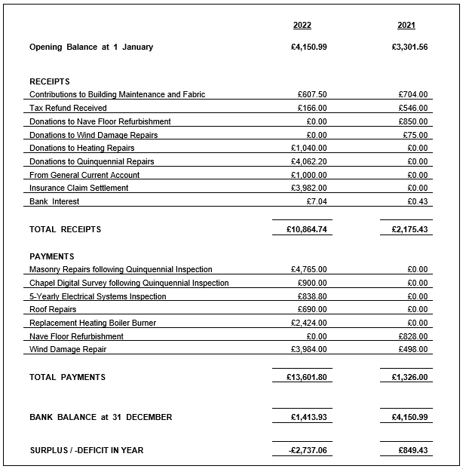

- External Giving Report
The amount to be considered for 2023 – £2,700
The group met on Wednesday 22nd February 2023. Following a discussion, the decision was made to continue to support our missionary family in Peru and local Christian charities that work with families in need, the homeless and addicted and those in need of free counselling services.
Donations for Daisy Chain and the North Air Ambulance Service were also agreed by the PCC as they carry out amazing work in our community and rely totally on charitable giving.

Recipients
Burgess Family – missionaries in Peru £400
A Way Out – Stockton – supporting women and families £400
The Moses Project – homelessness and drug addiction £400
CFM Lighthouse Project – provision of free counselling £400
North Air Ambulance – Based at Urlay Nook £400
Daisy Chain – Autistic children £300
Christian Aid – For their work in Ukraine £400
TOTAL £2,700
Cheryl Moore

- Churchwardens’ Fabric Report
The building remains in very good general condition.
In 2022 we had the regular 5-yearly quinquennial inspection by our architect, and his report identified a large number of necessary works. Fortunately many of the individual items were of pointing or repair to external walls which could be grouped into a single item.
The architect identified works in 3 categories:
- Required urgently (2 items)
- Required within 12 months (21 items – of which 14 were repointing)
- Required over the next 5 years (11 items – of which 3 were repointing)

Both the urgent items have been actioned and completed. One of the two items which the architect considered to be urgent was the digital scanning of the Londonderry Chapel due to gaps that were visible in the ceiling stonework which could have indicated settlement or subsidence. That scanning has been completed and indicates that there has been no recent movement. The settlement which has caused the gaps in stonework probably occurred shortly after the building was constructed.
Following on from the Architects report we were visited by the Arch Deacon on behalf of the Diocese who commended us all on what he thought was a very well kept and very well -run church here at St Marys. We would like to thank everyone involved for their input into the Quintennial Inspection as it required preparation of a considerable number of reports and records.
Only 1 of the 12-months items (some minor roofing work) remains outstanding and will be actioned when weather conditions are suitable. Most of the 5-year items have also been actioned. The remaining items being generally minor, but there is work required to some windows which will be expensive to deal with in due course.
The stone cross which was blown down from the top of the bellcote in 2021 has been replaced. That was also an item in the architect’s 5-year list.
We did have some issues with our heating in 2022, the heating boiler suffered a major failure in October 2022, but since the installation of a new burner we have had minimal issues , (the cost of this was £2,300 but it will however greatly extend the life of our existing boiler, which would have cost over £15,000 to replace)
Some work was required to the roof of the Londonderry Chapel at a cost of £690. That chapel roof was not replaced when the main roof was replaced in the 1990s, and so the repairs are not really unexpected.
We have set about instigating recommendations following on from the Arch Deacons visit including, producing digital photographic records of the church building and the grounds as well as valuable items in the church, PAT testing of all our electrical devices has been carried out .
We have had an inspection of our electrical systems and wiring (and passed as “Satisfactorily”), our fire extinguishers have been checked and serviced in line with current statutory regulations.
The plan/map of the Garden of remembrance and the graveyard (at the back of the church) has been updated. In this past year we have overseen 2 Christenings, 2 weddings and 2 funerals (as well as several internments of ashes in the Garden of remembrance )
Mark Nile / Terry Reed – Churchwardens

- Safeguarding Report
There have been no formal reported incidents of safeguarding during the period of 2022 /2023.
Training updates for all volunteers continues to be every three years.
Updates to the diocese Safeguarding policies are in place and Matt Levinson has taken the lead to ensure that these are being completed / undertaken in accordance with the policy.
I continue to encourage people to come forward should there be any concerns that they feel are appropriate for my attention. Contact details are on all access forums.
At the end of March there will be a forum for all Durham diocese safeguarding officers to meet in Durham providing support and enabling safeguarding personnel to share best practice as well as raise any concerns. The get together is an opportunity to share the safeguarding culture. I will be attending.
Christine Burnell

- Children’s Church Report
Children
The numbers of children attending St Mary’s Church continues to be small, we have a cohort who attend regularly approximately 5 with additional children taking the number up to 15, rarely do they all attend at the same time. The age range of the children is quite small, this has enabled them to work together in a more productive manner in developing their learning and understanding of God’s love and applying it in their daily lives.
The downside of the reduced numbers is that they lack the social stimulus and challenge that a wider group brings. They and I benefit when more children are present.
The confidence the children have is a direct result of our church family’s love and encouragement that they are given. They do love to show their efforts to everyone, well most of the time!
Activities / Venues
Due to the reduced numbers both of children and leaders, activities and venue have been affected.
The Wilson centre enabled the children and the leaders to be loud and expressive in a way that the Londonderry Chapel does not. The big boisterous games and challenges were enjoyed by all and focused the children in a way that excited their thinking and enabled them to interact with each other is a wonderful supportive way that left us all buzzing with joy.
The downside of the Wilson Centre is that at least 2 adults are needed. The transporting of supplies to and from church each week, and the clean up process could mean missing out on the fellowship at St Mary’s.
Future
The Londonderry works for now, our numbers are small, and the activities are catered for the children in that space, when the warmer weather arrives we will use outside the church more which the children love.
We continue to pray for future growth, increasing numbers and more support.
The older children are moving toward adolescence and their needs will grow as they do.
The children will continue to be encouraged to participate more in the service and to express their love of the Lord.
Links with the school continue as with the village community.
Christine Burnell

- Little Ted Report
The Wednesday morning Mother + Toddler group “Little Ted” has been going for over 15 years now.
We now continue to meet every Wednesday in term time from 9.00 to 11.00 and have tea & coffee while the children play and get to know each other.
The numbers attending each week do vary, but recently we have been getting around 8 children. Some of the mothers who attend are trying to spread the word to others in the village, for example at the school gate.
There is no charge for attendance.
At Christmas 2022 we had a children’s Christmas party in church, with food and games. Father Christmas visited, thanks to Lewis Ayers.
Edie Bainbridge and Jane Firth continue to attend, together with Margaret Taylor from The Willow Chase who is a great and very enthusiastic helper and very much enjoys it.
We comply with the Diocesan Safeguarding policy. Everyone who helps has been DBS checked.
New helpers are always welcome. We have an enjoyable social time, and it is not hard work.
Christine Ayers

- Godzone Report
This year we have continued to build on the successful history of Godzone and have hosted students from the school for their Leavers Service, for Harvest, Christmas, the school’s 50th Anniversary, and for Easter. Students have engaged really well and have enjoyed the materials the team has provided. My thanks to the wonderful team which has helped make these services possible. Since lockdown we have continued with a slightly different format, of students rotating around stations and this has helped make their whole experience more purposeful and easier for them to have time to engage and pray. Godzone station style events have been alternated with services to celebrate particular events and this seems to have worked well. In addition to engaging children, we wanted as a team to see how we might engage parents and show them that they are welcome and valued. We have therefore put effort into ensuring refreshments are available and that we have people who are free to welcome adults who attend. This has been great and has increased our presence in the village where we had previously had great contact with children at the school but less with their parents.
Matt Levinsohn

- Home Groups Report
At our March vision day we have contemplated what would help our home groups to grow both numerically and also in depth of faith. With that in mind we relaunched the two groups (with some additional new members) and did a bit of work re-envisioning the groups around discipleship and helping one another to make those links between the bible, and their lives; seeking to see what God is doing in us and among us. In addition, to build community between the groups we decided to meet every few sessions as the two groups together. These times have been good and have been opportunities to hear what is going on across the church. The aim was also for the joint sessions to be times when we could invite new people to see what the groups are about and to pick up some of the larger issues which might cross over between the groups. As yet we have not been able to use the joint meetings to invite new people to engage, but that remains the aspiration. The two groups are going well, and feedback has been positive. I am most grateful to the group leaders and to you all for committing to journey with one another in this way. In research on churches which grow, it is almost universal that a growing church has a strong focus on small groups and so I am delighted that continues to be a key part of what we do as a church.
The groups in the winter term looked at parables of Jesus; coming back to the basics of faith. In the spring term we moved on to think about the practices of Jesus which helped him develop as a rounded follower of God and what we might learn from him.
As we move further into 2023 we are going to continue the broad focus our groups have of helping one another to grow in faith and maintain the invitational culture. At some point this year we may need to start a new group in addition to the two existing groups but will see how things develop to evaluate if that is needed.
Matt Levinsohn

- Drop In / Community Lunch Report
It’s lovely to be able to report that Drop In is back to pre-covid numbers. The Wilson Centre was designated as a Warm Zone during the winter months and offered a warm welcome on Thursday mornings to anyone who wanted to pop in for a chat and a cuppa. Drop In is a place and time for friends to meet and catch up, we regularly have twelve or more regulars and several cyclists who stop by and also join us for community lunch. There is no charge for tea, coffee and biscuits but everyone donates what they want which means we raise money for local charities and St Marys. We have previously raised money for North Air Ambulance, The Alzheimer’s Society and St Mary’s church roof. We are currently collecting for new lightweight tables for use in church. Drop In is every Thursday and open from 10.30 till 12.30 and everyone is welcome. The Community Lunch, a popular outreach activity, ceased in March 2020 due to the Covid 19 epidemic. It was possible to hold a couple of lunches during 2021 before having to close once more due to a new strain of Covid. Lunches restarted in earnest April 2022. Early signs were not great. Attendance at the first couple of lunches was very poor however subsequent lunches have been very well attended and numbers have returned to pre-pandemic levels. Thanks as always go to the team – Eddie and Maurice Bainbridge, Terry Reed, Lynne and Richard Dennis and myself. All food as far as possible is home-made and the activity is self- supporting due to donations. Anyone from the village and surrounding area is welcome to join us on the second Thursday of the month starting at 12.20pm.
Terry Reed / Cheryl Moore

